3.1.1.2 Risk Assessment Template
Overview
Risk assessment primarily concerns assessing and prioritizing risks identified from 3.1.1.1. Risk assessment and prioritization can be done using the probability-impact risk assessment matrix. As the name suggests the two factors used to assess all risks are (i) probability of its occurrence and (ii) impact should it occur on the organization and/or the project.
Given below is the probability impact matrix (PIM) or the Risk matrix.
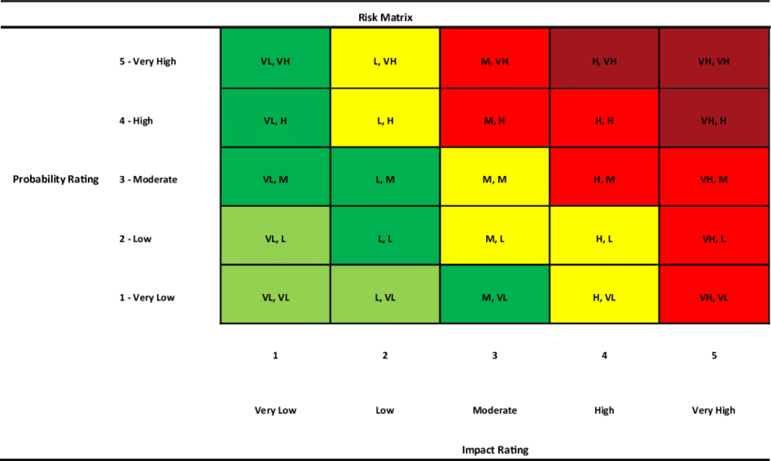
Kassem, M. A., Khoiry, M. A., & Hamzah, N. (2020). Using probability impact matrix (PIM) in analyzing risk factors affecting the success of oil and gas construction projects in Yemen. International Journal of Energy Sector Management, 14(3), 527–546. https://doi.org/10.1108/IJESM-03-2019-0011
All identified risks should be placed in one of the cells above in the probability impact matrix (PIM). Those risks occupying the red cells should be given priority as they are high impact, high probability risks.

Project Management Institute. (2021). A guide to the project management body of knowledge (PMBOK® Guide) (7th ed.). Project Management Institute.

 | Take Note

Example:
From the previous example [Template 3.1.1.1] we have identified the following set of risks for work package 1.1.1 Conduct stakeholder review, SC1: Stakeholders are available.
We also categorized risks as either low | medium |high based on three question assessment. The final summary of the risks are listed below. Only those risks categorized as Medium or High have been listed below in the table.

Question | Assumption | Risk Level
Q1 | Stakeholders see sufficient value or obligation to participate in the review. | Medium
Q1 | Stakeholders know that a interview is scheduled, its purpose, date, format and expectations. | Medium
Q1 | A common time can be agreed upon, particularly where multiple stakeholders are involved. | High
Q1 | Participation is not merely confirmed; stakeholders remain engaged for the required duration. | Medium
Q2 | Stakeholder sees no value, has competing priorities, or is dissatisfied with the project | Medium
Q2 | Stakeholders have incompatible schedules | Medium
Q3 | R9_Backup stakeholder/authorized representative | Medium

The next step involves placing them on the probability impact grid:

