1.1.1.6 Program and Policy-Procedure Score Template
The Program and Policy/Procedure Score Graph is a culmination of the Vision, Mission, Program and Policy/Procedure assessments performed earlier. The following are series of steps in constructing the graph.
This constitutes the final step where we perform results analysis by answering four sets of questions.
Step 1: Answer the following questions concerning the programs and policy/procedures
S. No. | Question | Score
1 (a) | Does the Vision and/or Mission statement have any supporting programs?  [Assign score 3n for Yes (where n = number of programs & 3 is Wt.) || 0 for No]
1 (b) | What are the assessment scores for the program/s?  [Assign scores calculated for each individual programs using template 1.1.1.3]
 | Program a
 | Program b
 | Etc.
Final Score for programs

2(a) | Does the Vision and/or Mission statement have any supporting policy/procedure?  [Assign score 2y (where y = number of policies/procedures) for Yes || 0 for No]
2(b) | If yes, what are the relevancy scores for the policies/procedures?  [Assign scores calculated for each individual policy/procedure using template 1.1.1.5]
 | Policy/Procedure a
 | Policy/Procedure b
 | Etc.
Final Score for policy/procedure

Step 2: Next, calculate the benchmarks and plot the Program and Policy/Procedure Score Graph.
Step 2.1: Calculate program benchmarks using the formulae provided below. Two benchmarks needs to be calculated (i) Minimum benchmark and (ii) Maximum benchmark.
Minimum Benchmark | Maximum Benchmark
PRG_{Min} = 7n  n=no. of programs | PRG_{Max} = 21n  n=no. of programs

Step 2.2: Calculate policy/procedure benchmarks using the formulae provided below. Two benchmarks needs to be calculated (i) Minimum benchmark and (ii) Maximum benchmark.
Minimum Benchmark | Maximum Benchmark
PP_{Min} = 2y  y=no. of policies | PP_{Max} = 6y  y =no. of policies

Step 2.3: Compute the median value for program/s and policy/procedure
Program | Policy/Procedure
PRG_{Med} = 14n  n=no. of programs | PP_{Med} = 4y  y =no. of policies

Step 2.4: Plot the Program and Policy/Procedure Score Graph.
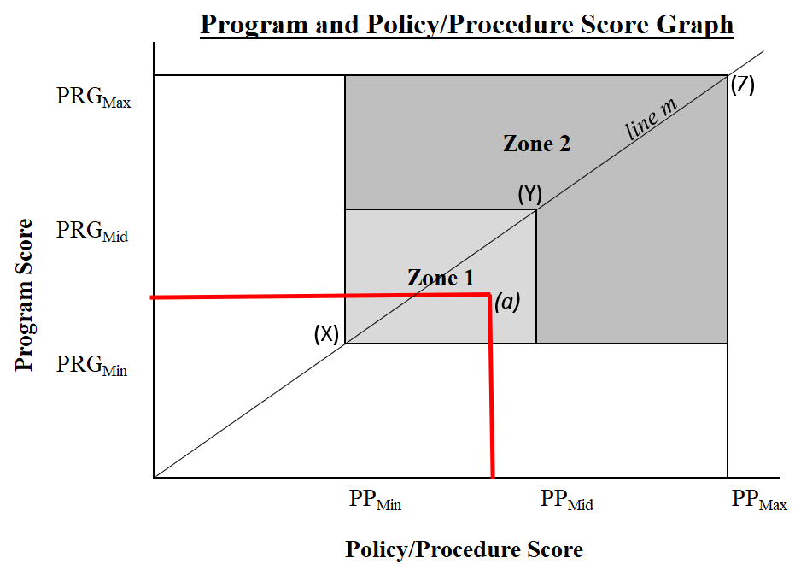
Figure 1: Program and Policy/Procedure Score Graph
(a) represents an experimental score for programs and policies/procedures.
Interpretation
- If the scores fall on X, discard all the current programs and policies/procedures. They are having no impact on the firm.
- If the scores falls anywhere on Zone 1, it is really up to the project team to decide whether to discard or to keep the programs and policies/procedures. Proximity of the scores to line m and to zone 2 can be used to make a decision. Line m (always with a 45º slope) represents equilibrium of the two scores. Other criteria can be used to arrive at a decision.
- If the scores fall on Y, it is on the mid point. Recommendation is to keep the programs and policies/procedures and try and improve them.
- If the scores fall on Zone 2, embrace both the programs and policies/procedures. They are already having meaningful impact and probably are important to the vision, values, ethos and culture of the organization. The closer the score to line m and to point Z, the stronger the case for keeping both the programs and policies/procedures.

